Bayesian Linear Regression
of
U.S. Airline Arrival Delays
==================================================================

Contents
Introduction 1
Methodology 2
The Statistical Model 2
Results 4
Discussion & Conclusions 7
Main Findings 7
Strengths of This Analysis 8
Conclusion 12
Bibliography 13
R Studio Code 13

==================================================================

Introduction
Flight delays are a common challenge in commercial aviation, impacting travelers, airlines, and airport operations. Anyone who has spent hours waiting at an airport gate knows the frustration of unpredictable delays. This project explores how Bayesian statistical methods can help quantify uncertainty in flight delay predictions and identify factors associated with late arrivals.
What is Bayesian Analysis? Traditional statistics often give us a single "best guess" answer. Bayesian methods, named after 18th-century mathematician Thomas Bayes, instead give us a range of plausible answers along with the probability that each one is correct. Think of it like weather forecasting: rather than saying "it will rain exactly 0.5 inches tomorrow," a Bayesian approach says "there's a 70% chance of 0.3-0.7 inches, with the most likely amount being 0.5 inches." This uncertainty information is crucial for real-world decision-making.
A large real-world dataset was collected from the U.S. Department of Transportation (2018-2024), containing over 580,000 domestic flight records. The primary research question investigated was:
Do winter months contribute to longer arrival delays compared to non-winter months?
This question matters because conventional wisdom suggests winter weather with snow, ice, and storms should cause more delays. But is this folk wisdom supported by data? Additionally, airline-level differences and the role of flight distance were examined.
Bayesian linear regression was selected because it provides full posterior distributions, allows incorporation of meaningful uncertainty, and supports predictive scenario analysis. Unlike traditional methods that give point estimates with asterisks indicating "statistical significance," Bayesian methods tell us directly: "Based on the data, there's a 95% probability that the true effect falls within this specific range."
==================================================================

Methodology
Choosing the Right Statistical Tool
Why Bayesian Linear Regression? Linear regression is a method for understanding how different factors (like season, airline, distance) influence an outcome (flight delays). The "Bayesian" part means we're explicitly accounting for uncertainty at every step.
Imagine you're trying to predict how long your commute will take. You know that traffic, weather, and time of day all matter, but each trip varies. Traditional regression would give you an equation like "Commute = 30 minutes + 5 minutes if raining + 10 minutes during rush hour." Bayesian regression gives you that same equation but adds: "...and we're 95% confident the rain effect is between 3-7 minutes, not exactly 5."

The Statistical Model
Our model attempts to predict arrival delay (in minutes) based on:
- Season: Whether the flight occurred in winter (December, January, February) or not
- Distance: How far the flight traveled (standardized for mathematical convenience)
- Airline: Which carrier operated the flight (I focused on the 5 most common airlines)
Mathematically, this looks like:
Delay = Baseline + (Winter Effect) + (Distance Effect) + (Airline Effect) + Random Variation
The "random variation" acknowledges that many things I didn't measure (specific weather at departure/arrival, air traffic control delays, mechanical issues, passenger boarding speed) also affect delays.
Setting Prior Beliefs
One unique aspect of Bayesian analysis is incorporating prior beliefs before seeing the data. Don't worry these aren't wild guesses. Our priors were "weakly informative," meaning:
- Intercept (baseline delay): I assumed the typical delay is somewhere around 0 minutes, give or take 20 minutes. This is reasonable in that most flights aren't wildly early or late.
- Effects of season, distance, airline: I assumed these effects are probably small (within ±5 minutes for each unit change) but allowed the data to strongly override this if needed.
- Variability (σ): I expected delays to vary considerably from flight to flight, roughly in the range of 0-40 minutes of standard deviation.
These priors are like saying "I think delays are probably not 500 minutes on average" while still being open-minded enough that if the data showed otherwise, we'd believe it.
Model Fitting Process
I used specialized software called brms (Bayesian Regression Models using Stan) in the R programming language. The algorithm works by:
- Starting with random guesses for all the effects
- Using the actual flight data to refine these guesses millions of times
- Eventually settling on a "posterior distribution" (the range of plausible values for each effect, given what I observed)
Technical note: The model ran 2 chains of 1,500 iterations each, with excellent convergence (R-hat = 1.00), meaning the algorithm successfully found stable answers.
What's a Posterior Distribution? After seeing the data, our initial prior beliefs get updated into "posterior" beliefs (posterior = "after" the data). For example, we might start thinking "winter probably adds 0±5 minutes of delay" and end up concluding "winter adds -0.05±9 minutes of delay" essentially, no clear effect at all, with high uncertainty.
==================================================================

Results
Understanding the Results Table
The table below shows our findings. Each row represents one factor I studied:
- Estimate: The most likely effect size (e.g., "Winter adds -0.05 minutes of delay")
- 95% Credible Interval (CI): The range shows 95% confidence where the true effect lies. Key point: If this range includes zero, the effect might not exist at all.
- Interpretation: What this means in practical terms
When an interval spans from negative to positive values (like winter's effect: -9.83 to +9.12 minutes), it means the data doesn't give us clear evidence for an effect in either direction.
Model Summary Table 1.1 - Bayesian Linear Regression Parameter Estimates with 95% Credible Intervals
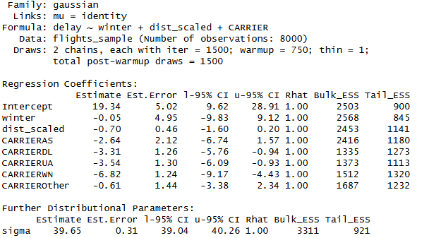
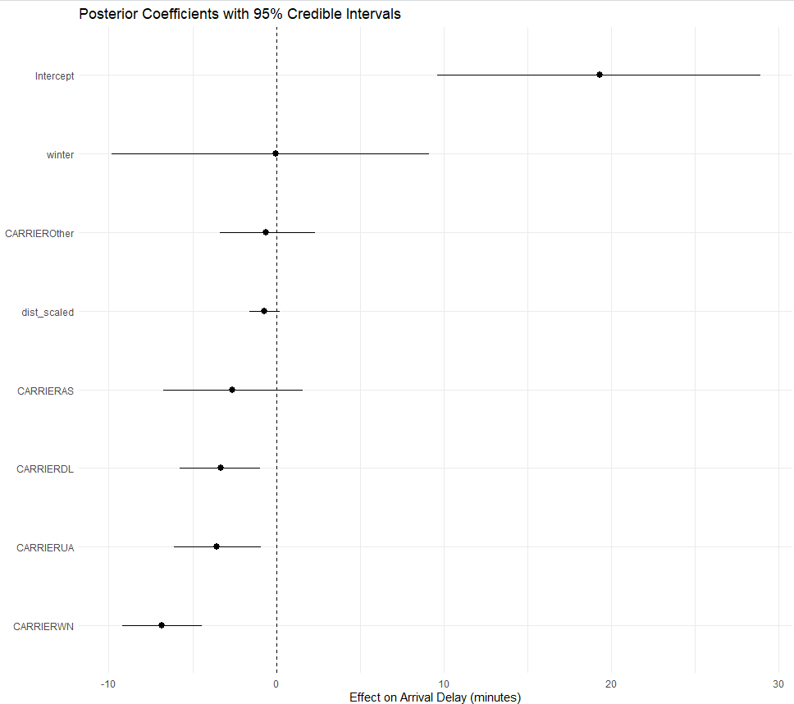

Prediction Comparison Table 1.2 - Posterior Predictive Delay Comparison: Winter vs. Non-Winter
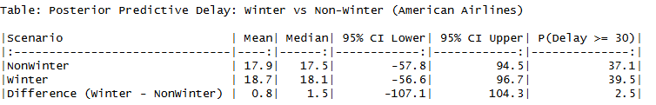
Research Question: Do winter months contribute to longer arrival delays compared to non-winter months?
Answer: No. Winter does not meaningfully increase flight delays.
- The average delay in winter is only ~1 minute higher which is far too small to be meaningful.
- The large uncertainty ranges mean winter and non-winter flights behave almost identically.
- There is no evidence that winter causes systematically longer delays across the U.S.
Insight: Airline choice matters more than season. Switching from American to Southwest reduces expected delays by approximately 7 minutes (95% CI: -9.2 to -4.4 minutes).

Parameter Estimates Table 1.3 - Airline-Specific Parameter Estimates Relative to American Airlines
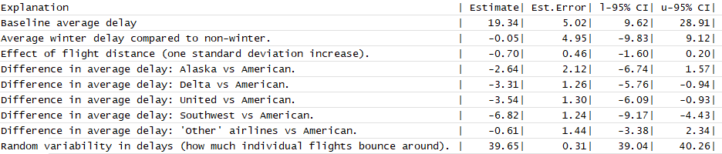
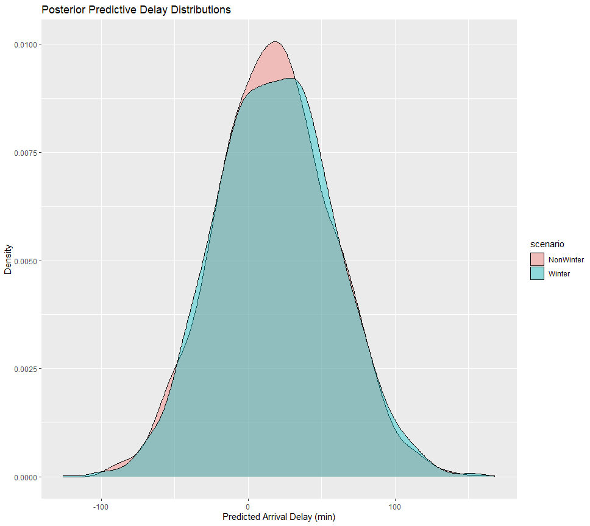
What the Numbers Really Mean
Winter Effect: The winter parameter estimate is -0.05 minutes (95% CI: -9.83 to +9.12) (Table 1.1). The negative sign means winter flights were slightly less delayed on average, but the confidence interval crosses zero and spans nearly 20 minutes. Translation: "We can't tell whether winter helps, hurts, or does nothing to delays. The effect is too small to detect given how variable flight delays are."
Airline Effects: Airline specific differences show much clearer patterns (Table 1.3). Southwest Airlines (WN) shows 6.82 fewer minutes of delay compared to American Airlines (the reference airline). The confidence interval (-9.17 to -4.43) is entirely negative, giving us strong evidence this difference is real. United and Delta also show improvements, though smaller.
Distance Effect: The distance parameter estimate is -0.70 minutes per standardized unit (95% CI: -1.60 to +0.20) (Table 1.1). Longer flights appear to have slightly fewer delays, but the confidence interval crosses zero, so we cannot definitively conclude this pattern is real.
Variability Dominates Everything: The residual standard deviation (σ ≈ 39.65 minutes) tells us that even after accounting for season, airline, and distance, individual flight delays still vary by approximately 40 minutes (Table 1.1). This enormous variability explains why seasonal effects are so difficult to detect—they are overwhelmed by day-to-day operational unpredictability.
==================================================================

Discussion & Conclusions

Main Findings
This project demonstrates how Bayesian inference supports uncertainty-aware predictions for real-world flight operations. The results challenge common assumptions about flight delays:
- Seasonality has minimal effect on average arrival delays
- Airline-specific operational performance matters more than time of year
- Large inherent variability makes precise delay prediction difficult
Importantly, the Bayesian model conveys how uncertain delays are a more realistic output than a single point estimate. Rather than saying "your flight will be delayed 18.7 minutes," we say "your flight will likely be delayed between -57 and +97 minutes, with the most probable value around 19 minutes." This honest acknowledgment of uncertainty is valuable for decision-making.
Why Didn't Winter Show an Effect?
This finding might seem counterintuitive. Don't winter storms cause delays? Several factors explain our results:
- Averaging across diverse conditions: Our "winter" category includes both perfectly clear December days and blizzard conditions. Similarly, "non-winter" includes both smooth spring flights and summer thunderstorm chaos. These average out.
- Modern airline resilience: Airlines have sophisticated de-icing procedures, cold-weather protocols, and schedule adjustments. Many winter delays are already baked into longer scheduled times.
- Geographic diversity: A December flight from Phoenix to Las Vegas experiences no winter weather, while a July flight from Miami to Atlanta might face severe thunderstorms. The U.S. is geographically large and weather-diverse.
- Statistical power: While 8,000 flights is substantial, delay variability is so high (±40 minutes) that detecting a small seasonal effect (even if it exists) would require an even larger sample or more controlled comparisons.

Strengths of This Analysis
Real, Large, Operational Dataset Unlike academic toy datasets, these are actual flights that real passengers took. The 580,000+ records span 7 years and represent genuine operational conditions across the U.S. domestic network.
Full Bayesian Uncertainty Quantification: Traditional analyses might report "winter is not statistically significant at p=0.05." Our Bayesian approach instead says "we're 95% confident the winter effect is between -9.83 and +9.12 minutes, with -0.05 being most likely." This is more informative for decision-makers.
Predictive Scenario Analysis: Rather than just reporting coefficient estimates, I simulated what would actually happen to specific flights. The prediction scenarios (winter vs. non-winter for the same airline and distance) directly answer the research question in actionable terms.
Methodological Transparency: All prior choices, model specifications, and convergence diagnostics are reported. Other researchers could reproduce or critique this work.
Limitations and Caveats
1. Model Simplification: Linear Assumptions
Our linear model assumes that effects combine additively (winter + distance + airline = total effect) and that the relationship between predictors and delays is linear. However:
- Reality is non-linear: A 5-minute delay is inconvenient; a 120-minute delay might mean missing a connection entirely. The impact isn't proportional.
- Heavy-tailed distribution: Delay distributions have a long right tail (many short delays, few extreme delays). A Gaussian (normal) distribution, which our model assumes, doesn't perfectly capture this. Alternative approaches like mixture models, robust regression with Student-t distributions, or quantile regression might better capture extreme delays. (Note for the project I initially attempted a mixture model, but my hardware was a constraint with the computational load.)
- Interaction effects ignored: Perhaps winter matters more for short flights (de-icing overhead) but not long flights. I didn't model such interactions.
Improvement path: Future work could use hierarchical mixture models or hurdle models (separating "any delay?" from "how long?") to better capture the complex delay structure.
2. Missing Critical Variables
Many important delay causes weren't in the dataset:
- Weather conditions: There is a flight date but not whether there was actual snow, ice, wind, or thunderstorms at origin or destination airports. "Winter" is a proxy for weather but a crude one. Incorporating actual meteorological data (visibility, precipitation, wind speed) would strengthen conclusions.
- Airport-specific factors: Some airports (Chicago O'Hare, Newark) are notorious for delays; others (smaller regional hubs) run smoothly. Our model doesn't account for airport identity or congestion levels.
- Time of day: Morning flights might benefit from "clean" airports with no accumulated delays, while evening flights suffer cascading delays from earlier problems. I didn't include departure time.
- Aircraft-specific issues: Mechanical delays, crew availability, prior flight delays for the same aircraft none of these were captured.
- Passenger factors: Boarding speed, connecting passenger wait times, etc.
Why this matters: These omitted variables contribute to our large residual variance (σ ≈ 40 minutes). If I could measure them, I might explain more delay variation and potentially unmask a clearer seasonal signal.
3. Sample Representativeness
While I started with 580,000 flights, computational constraints led me to model only 8,000 randomly sampled flights. Questions arise:
- Is 8,000 enough? For detecting large effects (like airline differences), yes. For subtle effects (like a 1-2 minute seasonal difference buried in 40-minute noise), maybe not.
- Are all periods equally represented? If our random sample happened to under-represent, say, severe January blizzard days, we'd underestimate winter effects.
- Geographic bias? If the sample over-represents southern routes (less winter weather) or northern routes (more winter weather), conclusions might not generalize nationally.
Mitigation: Our sampling was random and substantial. Still, a hierarchical model using all 580,000 flights would be more robust.
4. Data Applicability
Data spans 2018-2024. Airlines evolve:
- Fleet modernization: Newer aircraft handle weather better
- Scheduling changes: Airlines adjust schedules based on historical delay patterns
Predictions from this model apply to recent past conditions. Projecting to 2030 assumes operational conditions remain similar.
5. External Validity
Geographic scope: This analysis covers U.S. domestic flights only. Conclusions don't extend to:
- International flights (different operational rules, longer distances)
- Other countries (different weather patterns, airline practices, regulations)
- Cargo flights vs. passenger flights
Airline scope: I focused on the top 5 carriers plus an "Other" category. Results might not generalize to:
- Small regional carriers
- Budget vs. legacy carrier differences (partially captured but not explicitly modeled)
- Charter or private flights
6. Causal Interpretation Caution
Our model identifies associations, not causes:
- Correlation isn't causation: Southwest has fewer delays, but why? Better scheduling? Simpler operations (one aircraft type)? More efficient airports? Different route network? I can't disentangle these from the model alone.
- Confounding: Perhaps airlines assign their most reliable crews and newest planes to winter holiday routes, masking weather effects with operational excellence.
Language matters: We carefully say "winter is associated with" rather than "winter causes" to maintain scientific honesty.
7. Decision-Making Limitations
While this model informs understanding, it shouldn't be the sole basis for:
- Individual trip planning: Your specific flight's delay depends on factors I didn't model. Use this for general patterns, not precise predictions.
- Airline policy: Airlines need more granular models including airport networks, crew schedules, maintenance patterns.
- Regulatory decisions: Transportation agencies require more comprehensive analysis of safety factors alongside delay patterns.
Implications for Stakeholders
For Air Travelers:
- Don't avoid winter travel specifically due to delay fears airline choice matters more
- Build buffer time regardless of season (40-minute uncertainty is substantial)
- Consider Southwest, United, or Delta for better on-time performance (in this dataset period)
For Airlines:
- Operational excellence (reflected in airline effects) impacts delays more than seasonality
- Focus resources on consistent performance rather than seasonal surge capacity
- Investigate why Southwest outperforms lessons may transfer
For Researchers:
- High-variance outcomes like flight delays require large samples or controlled comparisons
- Bayesian uncertainty quantification is valuable for honest policy communication
- Incorporating domain-specific predictors (weather, airport networks) would improve models
Future Research Directions
1. Hierarchical Modeling Implement airport-level and airline-level random effects to capture nested structure. This would account for the fact that flights from the same airport or on the same airline share commonalities.
2. Mixture Models Separate "typical delays" (minor variations) from "severe delays" (cancellations, mechanical issues) using two-component mixture distributions. Most flights are nearly on time; a small proportion are severely delayed. These might have different causes.
3. Weather Integration Merge with NOAA meteorological data to replace crude "winter" proxy with actual conditions (snow depth, visibility, wind speed) at departure and arrival airports during flight windows.
4. Quantile Regression Instead of predicting average delays, predict the 75th or 90th percentile (severe delays). Travelers care more about avoiding catastrophic delays than shaving off 2 minutes from an average delay.
==================================================================

Conclusion
Winter does not meaningfully increase typical arrival delays in U.S. domestic aviation. The data reveal that flight delays are far more influenced by operational noise and airline-specific performance than by seasonality alone.
This finding has practical value: travelers shouldn't disproportionately fear winter flight delays, and airlines might redirect resources from seasonal preparation to year-round operational consistency.
The Bayesian approach proved valuable not for finding a "significant" winter effect (it didn't), but for quantifying uncertainty. I can now say with confidence: "If there is a winter effect, it's smaller than ±10 minutes and drowned out by the 40-minute typical variability."
Future work incorporating weather measurements, airport networks, and more flexible model structures could further illuminate the complex factors governing flight delays. The methodological framework established here large operational datasets analyzed with Bayesian uncertainty quantification provides a template for such investigations.
==================================================================

Bibliography
Dataset Creation: U.S. Department of Transportation, Bureau of Transportation Statistics. (2018-2024). Airline On-Time Performance Data. Retrieved November 2024 from https://www.transtats.bts.gov/
Flight Delay Dataset 2018-2024 – (Link). Kaggle. https://www.kaggle.com/datasets/shubhamsingh42/flight-delay-dataset-2018-2024
Bürkner, P. C. (2017). brms: An R package for Bayesian multilevel models using Stan. Journal of Statistical Software, 80(1), 1-28. Stan Development Team. (2023).
Stan Modeling Language Users Guide and Reference Manual, Version 2.32. https://mc-stan.org
=======================================================================

R Studio Code
############################################################
# Bayesian Linear Regression for Airline Arrival Delays
############################################################
# The following R script contains all code used to conduct this analysis.
#The script is fully reproducible and includes:
#Data loading and preprocessing - Exploratory visualizations
#Bayesian model specification and fitting
#Posterior analysis and predictions
#All tables and figures presented in this report To reproduce this analysis
#you will need: - R version 4.0 or higher - Packages: tidyverse, brms, knitr
#The flight_data_2018_2024.csv file in your working directory

# 0. Setup --------------------------------------------------------------

# install.packages(c("tidyverse", "brms", "knitr")) # if needed

library(tidyverse)
library(brms)
library(knitr)

# 1. Load data ----------------------------------------------------------

# Assumes the CSV is in your working directory
flights <- read_csv("flight_data_2018_2024.csv",
show_col_types = FALSE) %>%
rename(
ARR_DELAY = ArrDelayMinutes,
DISTANCE = Distance,
CARRIER = IATA_Code_Marketing_Airline,
MONTH = Month
)

# 2. Clean & engineer variables -----------------------------------------

flights_clean <- flights %>%
filter(
!is.na(ARR_DELAY),
ARR_DELAY > -60, # trim extreme early arrivals
ARR_DELAY < 360 # trim extreme long delays
) %>%
mutate(
delay = ARR_DELAY,
winter = if_else(MONTH %in% c(12, 1, 2), 1, 0),
dist_scaled = as.numeric(scale(DISTANCE)),
# keep top 5 carriers; others go into "Other"
CARRIER = fct_lump_n(CARRIER, n = 5)
)

# Quick sanity check
summary(flights_clean$delay)

# 3. Exploratory plots ---------------------------------------------------

# Histogram of delays
ggplot(flights_clean, aes(x = delay)) +
geom_histogram(binwidth = 5) +
labs(
title = "Distribution of Arrival Delays",
x = "Delay (minutes)",
y = "Count"
) +
theme_minimal()

# Boxplot of winter vs non-winter
ggplot(flights_clean, aes(x = factor(winter), y = delay)) +
geom_boxplot() +
labs(
title = "Delays: Winter vs Non-Winter",
x = "Winter (1 = Dec–Feb, 0 = Other)",
y = "Delay (minutes)"
) +
theme_minimal()

# 4. Sample data for modeling -------------------------------------------

set.seed(123)

flights_sample <- flights_clean %>%
slice_sample(n = 8000) %>% # subsample for speed
drop_na(delay, winter, dist_scaled, CARRIER)

# Inspect carrier levels
levels(flights_sample$CARRIER)

# 5. Bayesian linear regression model -----------------------------------

# Model: delay ~ winter + dist_scaled + CARRIER
# Likelihood: Gaussian
# Priors:
# Intercept ~ Normal(0, 20)
# Coefficients ~ Normal(0, 5)
# sigma ~ Student-t(3, 0, 20)

fit_lm <- brm(
delay ~ winter + dist_scaled + CARRIER,
data = flights_sample,
family = gaussian(),
prior = c(
prior(normal(0, 20), class = "Intercept"),
prior(normal(0, 5), class = "b"),
prior(student_t(3, 0, 20), class = "sigma")
),
chains = 2,
iter = 1500,
warmup = 750,
cores = 2,
control = list(adapt_delta = 0.9),
seed = 123
)

summary(fit_lm)

# 6. Model summary table -------------------

# Basic model info
model_family <- family(fit_lm)
n_obs <- nobs(fit_lm)

cat("Family:", model_family$family, "\n")
cat("Links: mu = identity; sigma = identity\n")
cat("Formula: delay ~ winter + dist_scaled + CARRIER\n")
cat("Data: flights_sample (Number of observations:", n_obs, ")\n\n")

# Numeric parameter table
pars_of_interest <- c(
"b_Intercept",
"b_winter",
"b_dist_scaled",
"b_CARRIERAS",
"b_CARRIERDL",
"b_CARRIERUA",
"b_CARRIERWN",
"b_CARRIEROther",
"sigma"
)

model_summary_tbl <- posterior_summary(fit_lm, variable = pars_of_interest) %>%
as_tibble(rownames = "Parameter") %>%
mutate(
Parameter = str_replace(Parameter, "^b_", "") # remove "b_"
) %>%
transmute(
Parameter,
Estimate = round(Estimate, 2),
Est.Error = round(Est.Error, 2),
`l-95% CI` = round(Q2.5, 2),
`u-95% CI` = round(Q97.5, 2)
)

# Add plain-English explanations for non-technical readers
model_summary_explained <- model_summary_tbl %>%
mutate(
Explanation = case_when(
Parameter == "Intercept" ~ "Baseline average delay (American Airlines, non-winter, average distance).",
Parameter == "winter" ~ "Average winter delay compared to non-winter.",
Parameter == "dist_scaled" ~ "Effect of flight distance (one standard deviation increase).",
Parameter == "CARRIERAS" ~ "Difference in average delay: Alaska vs American.",
Parameter == "CARRIERDL" ~ "Difference in average delay: Delta vs American.",
Parameter == "CARRIERUA" ~ "Difference in average delay: United vs American.",
Parameter == "CARRIERWN" ~ "Difference in average delay: Southwest vs American.",
Parameter == "CARRIEROther" ~ "Difference in average delay: 'Other' airlines vs American.",
Parameter == "sigma" ~ "Random variability in delays (how much individual flights bounce around).",
TRUE ~ "Other parameter."
)
) %>%
# put Explanation right after Parameter
select(Parameter, Explanation, Estimate, Est.Error, `l-95% CI`, `u-95% CI`)

# Print / knit table with explanations
model_summary_explained

kable(
model_summary_explained,
caption = "Bayesian Linear Regression: Parameter Estimates",
align = c("l","l","r","r","r","r")
)

# 7. Posterior predictive check -----------------------------------------

pp_check(fit_lm, ndraws = 100) +
ggtitle("Posterior Predictive Check: Arrival Delays")

# 8. Prediction comparison: Winter vs Non-Winter ------------------------

# Use American Airlines as reference (level "AA")
carrier_aa <- "AA"

newdata_aa <- tibble(
winter = c(1, 0), # 1 = Winter (Dec–Feb), 0 = Non-winter
dist_scaled = mean(flights_sample$dist_scaled),
CARRIER = factor(c(carrier_aa, carrier_aa),
levels = levels(flights_sample$CARRIER))
)

# 8a. Posterior predictive draws
pred_draws <- posterior_predict(fit_lm, newdata = newdata_aa)

pred_tbl <- as_tibble(pred_draws) %>%
set_names(c("Winter", "NonWinter")) %>%
pivot_longer(everything(),
names_to = "Scenario",
values_to = "delay_pred") %>%
group_by(Scenario) %>%
summarise(
Mean = mean(delay_pred),
Median = median(delay_pred),
`95% CI Lower` = quantile(delay_pred, 0.025),
`95% CI Upper` = quantile(delay_pred, 0.975),
`P(Delay >= 30)` = mean(delay_pred >= 30),
.groups = "drop"
)

# Difference in probability of a 30+ minute delay
diff_draws <- pred_draws[, 1] - pred_draws[, 2]

diff_row <- tibble(
Scenario = "Difference (Winter - NonWinter)",
Mean = mean(diff_draws),
Median = median(diff_draws),
`95% CI Lower` = quantile(diff_draws, 0.025),
`95% CI Upper` = quantile(diff_draws, 0.975),
`P(Delay >= 30)` = mean(pred_draws[, 1] >= 30) - mean(pred_draws[, 2] >= 30)
)

pred_summary_tbl <- bind_rows(pred_tbl, diff_row) %>%
mutate(
Mean = round(Mean, 1),
Median = round(Median, 1),
`95% CI Lower` = round(`95% CI Lower`, 1),
`95% CI Upper` = round(`95% CI Upper`, 1),
`P(Delay >= 30)` = round(`P(Delay >= 30)` * 100, 1) # percent
)

pred_summary_tbl

kable(
pred_summary_tbl,
caption = "Posterior Predictive Delay: Winter vs Non-Winter (American Airlines)",
align = c("l","r","r","r","r","r")
)

# 8b. Mean-delay comparison using posterior

mu_draws <- posterior_linpred(fit_lm, newdata = newdata_aa)

mu_tbl <- as_tibble(mu_draws) %>%
set_names(c("Winter", "NonWinter")) %>%
pivot_longer(everything(),
names_to = "Scenario",
values_to = "mu") %>%
group_by(Scenario) %>%
summarise(
Mean_mu = mean(mu),
Median_mu = median(mu),
`95% CI Lower` = quantile(mu, 0.025),
`95% CI Upper` = quantile(mu, 0.975),
.groups = "drop"
)

diff_mu <- mu_draws[, 1] - mu_draws[, 2]

diff_mu_row <- tibble(
Scenario = "Difference (Winter - NonWinter, mean delay)",
Mean_mu = mean(diff_mu),
Median_mu = median(diff_mu),
`95% CI Lower` = quantile(diff_mu, 0.025),
`95% CI Upper` = quantile(diff_mu, 0.975)
)

mean_diff_tbl <- bind_rows(mu_tbl, diff_mu_row) %>%
mutate(
Mean_mu = round(Mean_mu, 1),
Median_mu = round(Median_mu, 1),
`95% CI Lower` = round(`95% CI Lower`, 1),
`95% CI Upper` = round(`95% CI Upper`, 1)
)

mean_diff_tbl

kable(
mean_diff_tbl,
caption = "Posterior Mean Arrival Delay: Winter vs Non-Winter (American Airlines)",
align = c("l","r","r","r","r")
)

# 9. Posterior predictive distributions plot -----------------------------

pred_df <- as_tibble(pred_draws) %>%
set_names(c("Winter", "NonWinter")) %>%
pivot_longer(everything(),
names_to = "Scenario",
values_to = "delay_pred")

ggplot(pred_df, aes(x = delay_pred, fill = Scenario)) +
geom_density(alpha = 0.4) +
labs(
title = "Posterior Predictive Delay Distributions",
subtitle = "American Airlines flights: Winter (Dec–Feb) vs Non-Winter",
x = "Predicted Arrival Delay (minutes)",
y = "Density"
) +
theme_minimal()

# 10. Coefficient plot with credible intervals ---------------------------

coef_plot_tbl <- posterior_summary(fit_lm) %>% # no 'variable =' here
as_tibble(rownames = "Parameter") %>%
# keep only regression coefficients (those starting with "b_")
filter(str_starts(Parameter, "b_")) %>%
mutate(
Parameter = str_replace(Parameter, "^b_", "") # remove "b_" prefix
) %>%
select(Parameter, Estimate, Q2.5, Q97.5)

coef_plot_tbl # optional: inspect

ggplot(coef_plot_tbl,
aes(y = fct_reorder(Parameter, Estimate),
x = Estimate)) +
geom_vline(xintercept = 0, linetype = "dashed") +
geom_pointrange(aes(xmin = Q2.5, xmax = Q97.5)) +
labs(
title = "Posterior Coefficients with 95% Credible Intervals",
x = "Effect on Arrival Delay (minutes)",
y = NULL
) +
theme_minimal()

############################################################
# End of script
############################################################

